ENGLISH LANGUAGE CONVERSATION CLUB

You’re invited to join UMIB’s English Language Conversation Club!
Practice your English and learn about American culture in a casual environment with the help of an American.

Fill out the forms below to join (via links)

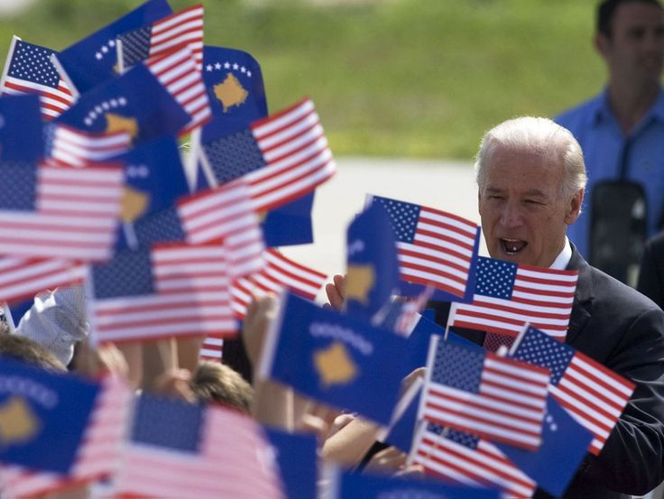

WHO: Students in grades I - IV in the Faculty of Education at UMIB.

WHAT: In groups, express yourself in English through music, games, literature, poetry, and art. Explore current affairs, culture, and history. Present your ideas through different media models- news journalism, radio broadcast, and social media. Enjoy parties for American holidays!

WHEN: Weekly meetings for multiple groups during non-lecture hours. Schedule to be determined based on your availability.

WHERE: Location at the university to be determined.

Direct any further questions to Sara at sarasaj@udel.edu.

Fill out the forms below to join via links.

https://goo.gl/forms/EPPSCMmo5U6d6hLT2

https://doodle.com/poll/stbettty2877ufbq

